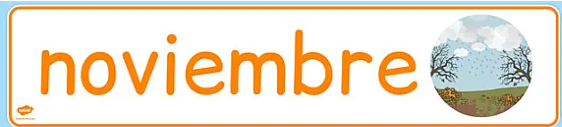

Domingo Lunes Martes Miércoles Jueves Viernes Sábado

|  |  |  |  |  |  |  |
| --- | --- | --- | --- | --- | --- | --- |
|  |  |  |  |  | 1  La enfermera de la escuela comenzará este mes a realizar pruebas oculares. | 2 |
| 3 | 4 | 5  **No hay escuela** | 6 | 7 | 8 | 9 |
| 10 | 11  **No hay escuela** | C:\Users\VSteed\Pictures\Screenshots\Screenshot (17).png12 | 13 | 14 | 15 | 16 |
| 17 | 18 | 19  **Día de toma de fotografías** | 20 | 21 | 22 | 23 |
| 24 | 25 | 26 | 27  **Salida anticipada**  **No hay clase por la tarde.** | Thanksgiving infographic (in spanish) by The Teacher's Inventor | TPT28 | 29 | 30 |